**PRACTICAL 18:**

**TABLE MAKING**

**CODE:**

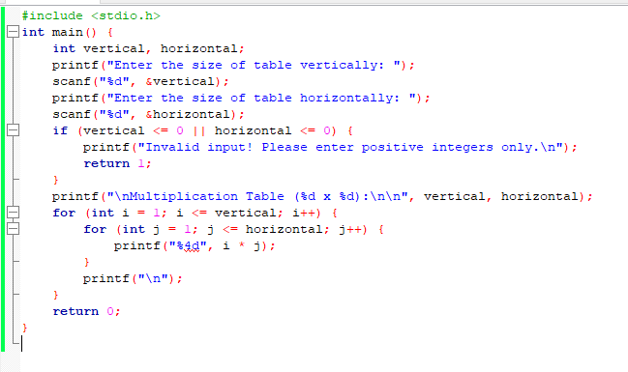

**OUTPUT:**

